SQL Practice exercises

Goal: Put into practice what you have learned so far in the SQL lectures (basic queries and more advanced queries)

There are 15 questions to solve with queries that are roughly of increasing difficulty:

* Level 1: Stretching
* Level 2: Pouring some spices
* Level 3: Why so serious?

**The document to submit should be either a doc file or a pdf file with the answers to each question:**

1. **The query you ran**
2. **The result you got**

# Setup instructions

1. [Download the repository](https://github.com/datacharmer/test_db/archive/refs/heads/master.zip). Unzip the file.
2. Launch your terminal/command shell and go to the repository where you downloaded the file. Enter the folder (that you have unzipped).
3. Run the following command: *mysql -u root -p < employees.sql*

You should see the tables loading:

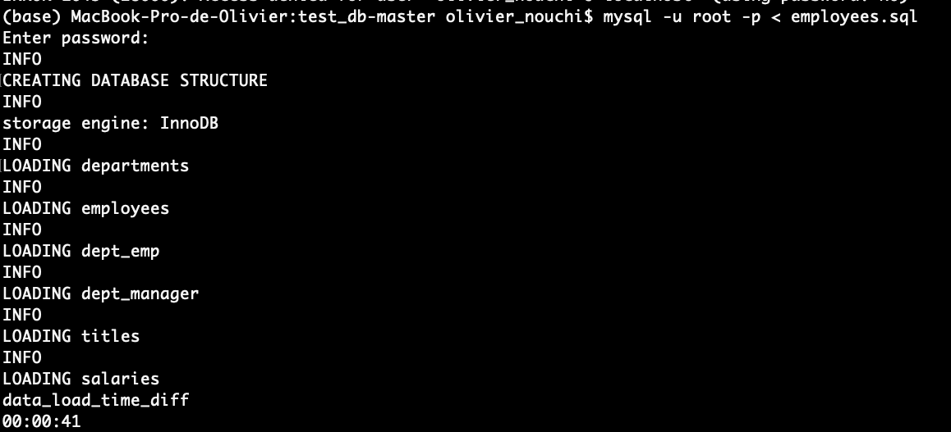

You have created the employees’ table with the tables cited above.

1. Then run the following command line: *mysql -u root -p -t < test_employees_md5.sql*

It will make sure that you have loaded everything correctly. You should be able to see the following (records matched).

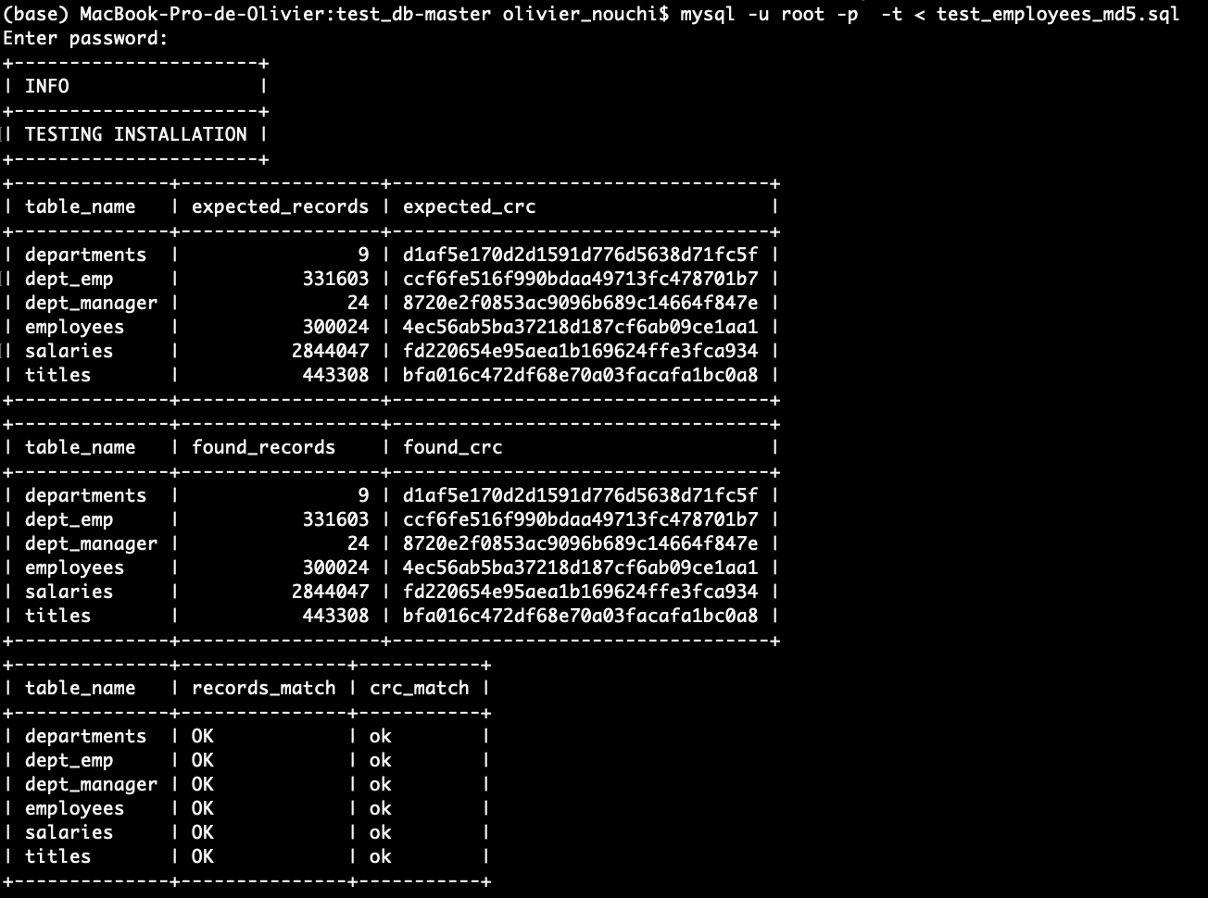

You are all set!

You can now work in MySQL Workbench.

Don’t forget to “Refresh All” if you don’t see it appear in MySQL Workbench.

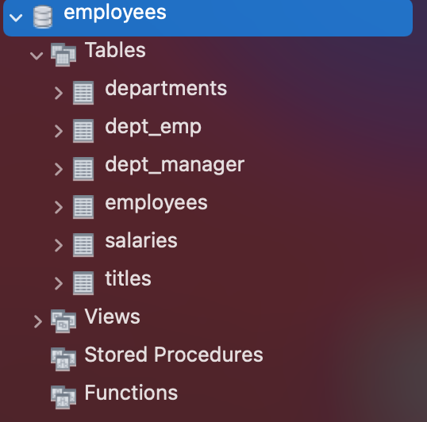

# Database schema

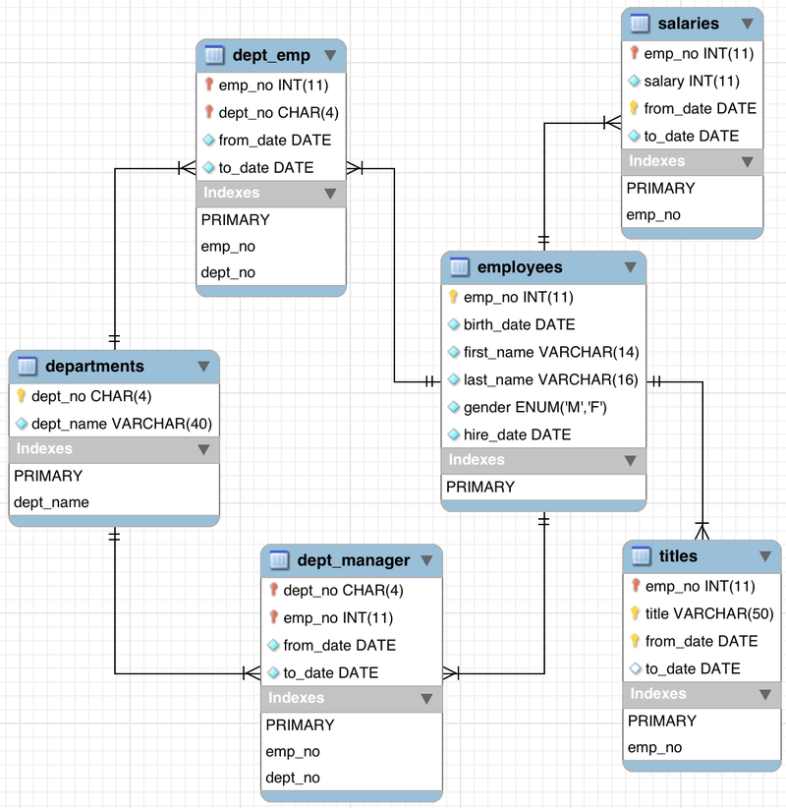

# 

# 

# Stretching

Q1 - How many unique employees are there?

Q2 - How many males and females employees are there? Order the counts in descending order.

Q3 - Display the year and total hires for the year with the most hires

Q4 - What is the name of the department with the most employees

Q5 - How many employees were born on November 12? What's the percentage out of all the employees?

Q6 - What are the 3 most common employee titles (display the employee titles and the number of times they occur)

Q7 - Find the avg salary for each department (department name). Round to the nearest integer and order by avg salary from the highest to the lowest.

# Pouring some spices

Q8 - Find the average salary by employee title. Round to 2 decimals and order by descending order

Q9 - Find the number of employees who have worked in at least 2 departments

Q10 - Get the distribution of the year of the hire dates. (hint: you should end up with a number of employees per year of hiring date)

Do you notice any pattern? Assuming there is no missing data, is the company hiring more or less as time goes by?

Q11 - Display the first name, last name, and salary of the highest paid employee

Q12 - Display the first name, last name, and salary of the THIRD highest paid employee

# Why so serious?

Q13 - Display each department name and the age of the youngest employee at hire date

Q14 - What's the range of age the employees would be today (calculate their age whole years)

Q15 - How many employees were born on the same date (day-month-year) as those born in 1955

NB: Change the according to preferences parameters if your query fails because of a timeout